Line Test Results for CAM 3 on Goldflake Superstar Blue :-   
  
These tests are done for 3 kind of defects in Cam 3 images:-

* Short Mitre - defective or non_defective ( 2 classes)
* Long_Mitre - defective or non_defective ( 2 classes)
* Label – Defective or non_defective ( 2 classes)

Line Tests are done for 3 different time:

1. 29 June 9.25 am to 12.10 pm (10705 packets were checked)
2. 29 June 1.34 pm to 5.08 pm (13850 packets were checked)
3. 30 June 0.15 am to 9.24 am (58291 packets were checked)

Files are uploaded on google drive

<https://drive.google.com/drive/folders/1s0cQCpILOyeXb26kAMfAcBypz8tlpEDk?usp=sharing>

1. Total packets checked 10705

Short Mitre

Defective Predicted were 20 items :

Correct prediction 7

Camera error 1

Long seam detected in picture 2 (checked also occuring as defect in long seam)

False detection:

Double Packet issue 9 (Can be solved by increasing dataset)

Good image but predicted defective 1

Long Mitre

Defective Predicted (10 items)

Correct prediction 8

Camera error 1

False detection 1 (trigger capturing error)

Bottom Label

Defective Predicted (5 items)

Long seam captured 4 (all 4 images also part of long seam defective)

False Detection 1 (trigger capturing error)

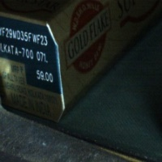

2) Total packets checked 13850

Short Mitre

Defective Predicted were 19 items :

Correct prediction 12

Long seam detected in picture 3 (2 of them also part of long seam defective)

False detection:

Good image but predicted defective 4 (need to increase dataset)

Long Mitre

Defective Predicted (12 items)

Correct prediction 10

False detection :

1 (trigger capturing error)

1 orientation packet error



Bottom Label

Defective Predicted (14 items)

Long seam captured 3 (all 3 images also part of long seam defective)

False Detection 13 (trigger capturing error and double packet image)

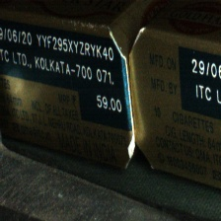 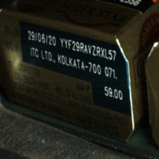

3) Total packets checked 58291

Short Mitre

Defective Predicted were 102 items :

Correct prediction 64

Long seam detected in picture 20

False detection:

Double Packet issue 2 (Can be solved by increasing dataset)

Good image but predicted defective 16

Long Mitre

Defective Predicted (112 items)

Correct prediction 81

Camera error 3

False detection:

1 (trigger capturing error)

27 (double packet captured)

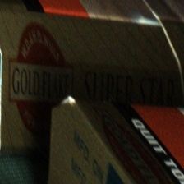

Bottom Label

Defective Predicted (61 items)

Long seam captured 34

False Detection:

6 trigger error

21 false detection ( no pattern found)